8.7: 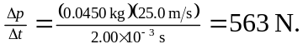 The weight of the ball is less than half a newton, so the weight is not significant while the ball and club are in contact.

